Introduction to AI

Artificial Intelligence (AI) is the ability of a computer or machine to think and make decisions like humans. It uses data, logic, and algorithms to solve problems, recognize patterns, learn from experience, and perform tasks.

Types of AI :
1. Narrow AI (Weak AI):
- Definition: AI that is designed to do one specific task.
- Examples:
- Siri or Alexa (voice assistants)
- Google Maps (navigation)
- Face recognition in phones
- Limitations: It cannot think or learn beyond its specific function.

2. General AI (Strong AI):
- Definition: AI that can think, learn, and make decisions like a human.
- Examples: No real example yet (still being developed).
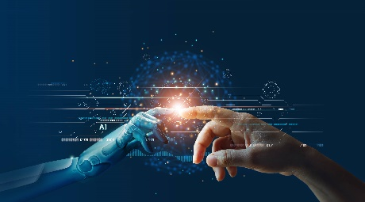
- Abilities: It would be able to do any task that a human can do — learn new things, understand emotions, solve problems, etc.
USES of AI:
1. Healthcare :
-Disease diagnosis (e.g. cancer detection).
- Medical imaging.
- Virtual health assistants.
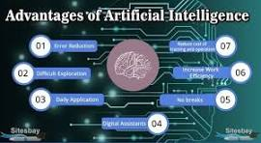

- Drug discovery.

2. Education :
- Personalized learning apps.
- Automated grading.
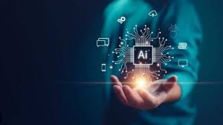
- Chatbots for student queries.

3. Business :
- Customer support (AI chatbots).
- Fraud detection in banking.

- Sales prediction and data analysis.


4. Transport :
- Self-driving cars.
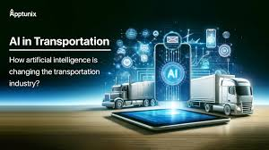
- Traffic prediction (e.g. Google Maps).
Advantages of AI :
Artificial Intelligence offers many advantages that make work easier, faster, and more efficient. One of the biggest benefits is automation, which allows machines to perform repetitive tasks without getting tired, saving both time and labor costs. AI also improves accuracy in fields like healthcare, where it helps in early disease detection and diagnosis. In education, it helps personalize learning for students. AI can also analyze large amounts of data quickly, helping businesses make better decisions. Furthermore, AI-powered tools like chatbots and virtual assistants make daily life more convenient by answering questions or controlling smart devices. Overall, AI increases productivity and enhances our ability to solve complex problems.

Disadvantages of AI :
While AI brings many benefits, it also has some disadvantages. One major concern is job loss, as machines can replace humans in many industries, leading to unemployment. AI systems are also expensive to develop and maintain, requiring advanced technology and skilled workers. Another issue is lack of human emotions—AI cannot truly understand feelings or show empathy, which is important in areas like healthcare or counseling. AI can also be biased or make wrong decisions if it is trained on incorrect or unfair data. Lastly, there is a risk of over-dependence, where people might rely too much on AI and lose their problem-solving skills. In some cases, AI can also raise privacy and security concerns if misused.

The moral of AI is that while artificial intelligence can greatly improve our lives, it must be developed and used responsibly. We should ensure that AI is fair, safe, and ethical, without harming people or replacing them unfairly. Humans must stay in control of AI and use it to support humanity, not dominate it. The key lesson is: with great power comes great responsibility.

